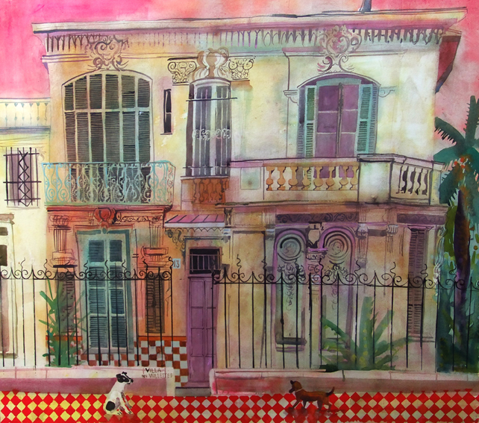

Paint in Andalusia
With Jenny Wheatley RWS NEAC and Mike Chaplin RWS RE
May 14th-28th 2017
Jenny and Mike will be taking a small group to Andalusia for the first time this year. We will stay in the heart of the old quarter of Priego de Cordoba, at the Casa de la Villa. The town is about half way between Malaga and Cordoba and is described as one of the prettiest towns in Andalusia. The hotel is small so early booking is essential. If we have more customers than rooms we will provide accommodation nearby as well, and use the facilities of the hotel as our base. There is a spa and hamam in the hotel, and the holiday’s painting matter will incorporate the white washed Spanish buildings as well as the Moorish influence, along with stunning views out over the surrounding landscpe.
We will follow our usual style of tuition, Mike offering the voice of reason with technical pearls of wisdom and sound tonal and traditional techniques, and Jenny will immerse you in colour and emotive responses to your environment. The area and subject matter are perfect for experimenting and loosening up in your approach as well as encompassing the vital basics of drawing and painting. There will be number of critiques during the fortnight and painting topics provided as well as individual tuition as always.
Evening meals will be taken in a selection of restaurants within the town and the tapas and local specialities will feature highly. We will stay within the town and will explore all the nooks and crannies on offer by foot.
The price includes tuition, accommodation in single occupancy en suite rooms, breakfast and dinner as well as flights, transfers and transport during the holiday. Non painting partners are welcome to join us but there is not a reduction for this. For anyone wishing to share a room there is a £100 reduction per person. Course price. £2495 for 2 weeks.
