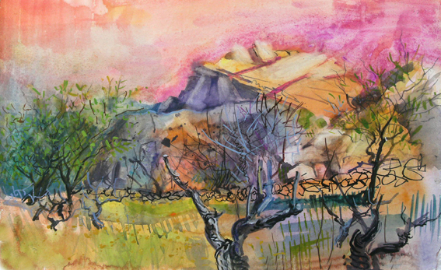

Paint in Cyprus
with Jenny Wheatley RWS NEAC and Mike Chaplin RWS RE
September 16th-30th 2017
Jenny and Mike have taken courses in Cyprus several times, always in the Paphos district but in the quiet north west of the Akamas which is the area of Greek Cyprus where Jenny lived for a year some time ago. Because of our long association with the area we are able to take you to some of the most secret and remote gems that the area has to offer, from tiny villages to remote bays, lush valleys to Byzantine chapels. As well as discovering the quieter subject matter of the region there will also be a chance to visit and draw at some of the many important archaeological sites that the area has to offer.
The Droushia Heights Hotel, where we have stayed before, is situated on the edge of the old village of Droushia and affords splendid views down to the bays surrounding Polis as well as over the rocky outcrops of Akamas (the area once inhabited by the fleeing armies from the Trojan wars and where rumour has it that 100 tiny churches remain hidden in the now abandoned landscape). From the hotel terrace one can also look across to the high Troodos mountains and the olive and fruit groves of the valleys. The village itself is very traditional and quiet and there is a church, a few grocery stores, some traditional cafes and a couple of lovely tavernas where we will sample varying mezes each night. The hotel has a large pool and breakfasts will be taken either in the dining room or on the terrace where the views are stunning.
We will follow our usual style of tuition, Mike offering the voice of reason with technical pearls of wisdom and sound tonal and traditional techniques, and Jenny will immerse you in colour and emotive responses to your environment. The area and subject matter are perfect for experimenting and loosening up in your approach as well as encompassing the vital basics of drawing and painting.
The price includes tuition, accommodation in single occupancy en suite rooms, breakfast and dinner as well as flights, transfers and transport during the holiday. Non painting partners are welcome to join us but there is not a reduction for this. For anyone wishing to share a room there is a £100 reduction per person. Course price. £2495 for 2 weeks.

